Administration Assistant  CE SCHEME | 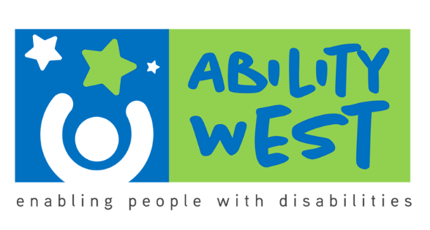
 | Ability west community employment scheme are recruiting an Administration Assistant in Ballybane, Galway
General Duties Include
- Based in the organisation’s training building in Ballybane supporting the Training Coordinator and the CE Scheme Training activities
- Reception duties for the training building.
- Scheduling training and meetings, maintenance of the training database, typing, emailing and reception desk duties.
Training Provided
- Mandatory Ability West Internal Training
- Specific training tailored to meet your career needs
Requirements
- Garda Vetting will be required for this role
- Must be in receipt of a Social Welfare Payment for 12 months

For further information please call
Breda Kerans – CE Supervisor – 087 675 1415

CE Scheme Vacancy, Ballybane, Galway City

